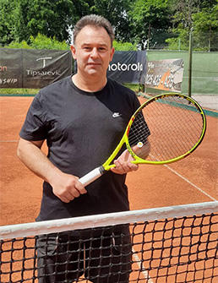
Sunny Dimic
Club Coach
Sunny joins Pit Farm Tennis Club with great experience in teaching adults and juniors of all ages and abilities. He has previously managed several prestigious clubs in London and surrounding areas. He is passionate about what he does and gets great satisfaction from watching his students develop and improve the technical, tactical, physical and mental aspects of their tennis. Lessons are devised to suit individuals, smaller or larger groups. In his lessons Sunny will employ different teaching techniques to help you improve your game. His teaching philosophy is very simple: “I want you to have enjoyment while playing better tennis”
Sunny was Top 20 as a junior in ex-Yugoslavia, playing competitively against players such as Goran Ivanisevic. Coached Filip Krajinovic (highest ATP ranking 26) when visiting hometown during summer holidays.
Sunny holds LTA Level 4 Club Coach Award & LTA Accreditation +
Individual Lesson: £45
Two players: £50 (£25 each)
Three players: £60 (£20 each)

Mobile contact: 07498 740 794
Email: dimics1968@gmail.com

